**Clinical Procedures for Medical Assistants**

**Career Education Center**

**Chapter 1**

**The Medical Record**

**Chapter 2**

**Asepsis**



Name

Period

Medical Assistants clinical responsibilities

Circle 5 skills that you think you would enjoy most.

* Helping the patient prepare for exams and other procedures
* Recording the medical history
* Assisting with exams
* Cleaning and sterilizing instruments
* Instructing patients about laboratory exams
* Keeping supply cabinets stocked
* Conforming with OSHA standards
* Supplying patient education
* Performing a variety of lab tests such as urinalysis and EKG
* Taking vital signs
* Preparing treatment or surgical trays
* Taking patients to the exam rooms

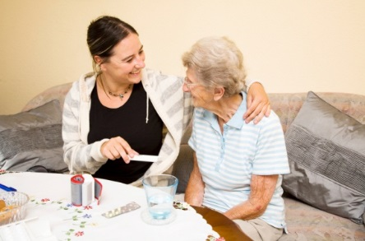

Frequently Asked Questions of Medical Assistants (MA) :

1. Are MAs required by the state of California to be certified? Yes ___ No ____
2. Are MAs allowed to start or disconnect IVs ? Yes ___ No ____
3. Are MAs allowed to give nasal smears? Yes ___ No ____
4. Are MAs allowed to start perform finger sticks? Yes ___ No ____
5. Are MAs allowed to start swab the throat for a culture? Yes ___ No ____
6. Are MAs allowed to insert urinary catheters? Yes ___ No ____
7. Are MAs allowed to inject collagen? Yes ___ No ____
8. Are MAs allowed to start interpret the results of a skin test? Yes ___ No ____
9. Can MAs call in refills to a pharmacy? Yes ___ No ____

Chapter 1: the Medical Record

HIPAA (page 4)

The HIPAA Privacy Rule:

True or False?

1. Pts have a right to see where their information was used, other than for treatment, payment or operations ________
2. The medical office must have training on privacy and security of PHI for all _______
3. Can you think of a way PHI could be accidentally disclosed? _________________________________________________________________________________________________
4. If the Medical Office does not comply penalties can include: _________________________________________________________________________________________________

HIPAA QUIZ

1. Pt wants records sent to another doctor because he is moving.

Does he have to sign a release? ___________________

1. Pt wants records sent to X-ray within the group.

Does he have to sign a release? ___________________

1. The office manager wants to review the chart.

Does he have to sign a release? ___________________

1. The pt is sent to a cancer specialist (oncologist) within the group.

Does he have to sign a release? ___________________

1. A man wants to see the results of his elderly father’s blood tests.

Does the father have to sign a release? ___________________

1. If the need to see the records is part of treatment, payment or operations within the group, Does he have to sign a release? ___________________
2. The mother of a 20 year old pt. wants to see her son’s record.

Does he have to sign a release? ___________________

Case Study 1: (page 5)

_____________________________________________________________________________________________________

_____________________________________________________________________________________________________

_____________________________________________________________________________________________________

_____________________________________________________________________________________________________

Progress Notes:

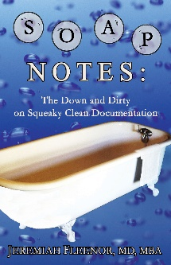SOAP stands for: (page 28)

S___________________________________________________________________________________________________

O___________________________________________________________________________________________________

A___________________________________________________________________________________________________

P___________________________________________________________________________________________________

SOAP Quiz: on the following symptoms, write “S” by the subjective *& “O” by the objective. Be prepared to spell the underlined words correctly.

1. A large bruise
2. An upset stomach
3. Nausea and Vomiting x 2 days.
4. Temperature of 98.6 F
5. A tooth ache
6. Sore throat x 3 days.

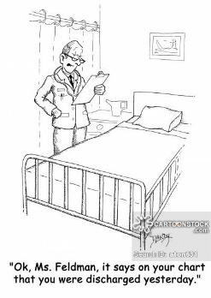Chief Complaint (CC)

Read the bullets under “chief complaint” page 34

* Never diagnose. Just write the ____________________________________________________________
* Include 3 parts of a good chart note (given by the instructor)
  + __________________________________________________
  + __________________________________________________
  + __________________________________________________

CC Quiz: write “C” if correct, or “I” if incorrect in the following examples:

1. Pain in the left foot that started 5 days ago, not taking any medication.
2. Urinary tract infection for 3 days, taking 2 glasses of Cranbury juice.
3. Large swelling on ring finger for 2 days
4. Pt. states “pain when urinating “ x 3 days
5. Pt. feels sick, probably due to overeating since she is really fat.

Correct the following chart notes to read “7 mm”

* *The three parts to good chart notes are:*

*Where it hurts*

*When did it start.*

*Are you taking any medications?*



* *Medical Assistants NEVER diagnose*

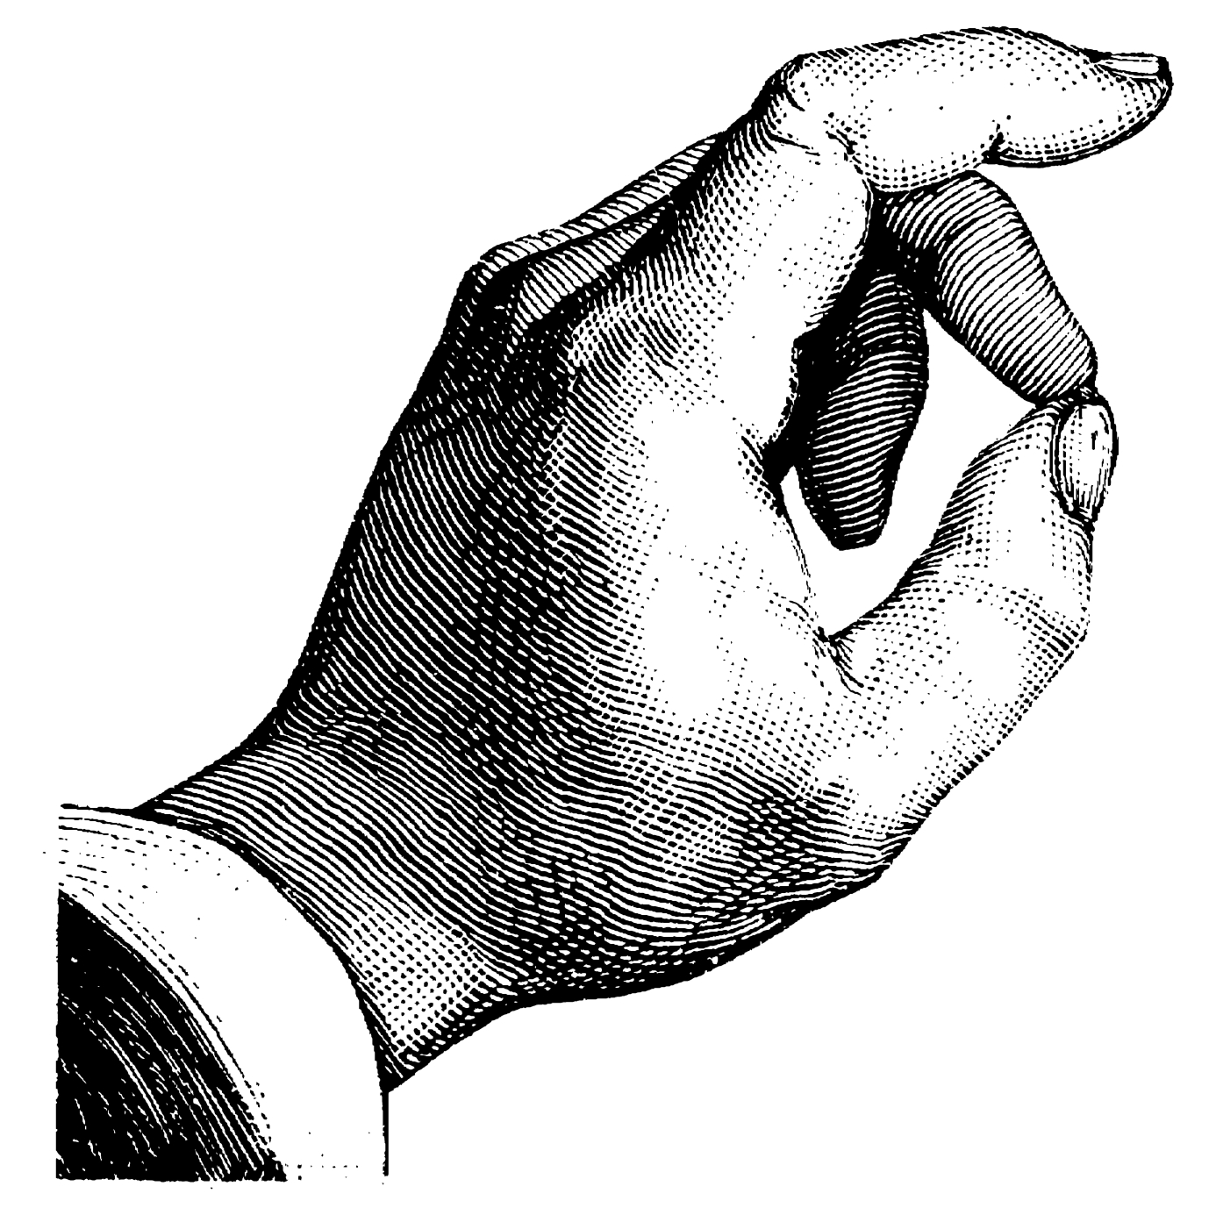

* *Always sign your name and title*

*Q:\140066.enu\MEDIA\CAGCAT10\j0240719.wmf*

* *To correct a chart:*

*Cross it out with one line*

*Write the correction*

*Write your initials and the date.*

|  |  |
| --- | --- |
| *5-12--2013* | *.*  *TB test results are 5 mm.______LBrammer,MA* |
|  |  |

Correct the following chart notes to read “120/80”

|  |  |
| --- | --- |
| *5-12--2013* | *BP: 140/90 _________________L.Brammer,MA* |
|  |  |

Charting.

Why do you think chart notes should be in black ink?

Procedure 1;4: page 45. Record patient symptoms:

Read the examples on page 46, then take chart notes.

|  |  |
| --- | --- |
| Date | Pt name  DOB |
|  |  |
|  |  |
|  |  |
|  |  |
|  |  |
|  |  |
|  |  |



To describe pain O= Onset,

Remember OLD: L= Length of time since it started.,

D= Degree of pain (0 none, to 10 very bad)

On a picture of a “patient”, label the following body parts and be able to spell them.

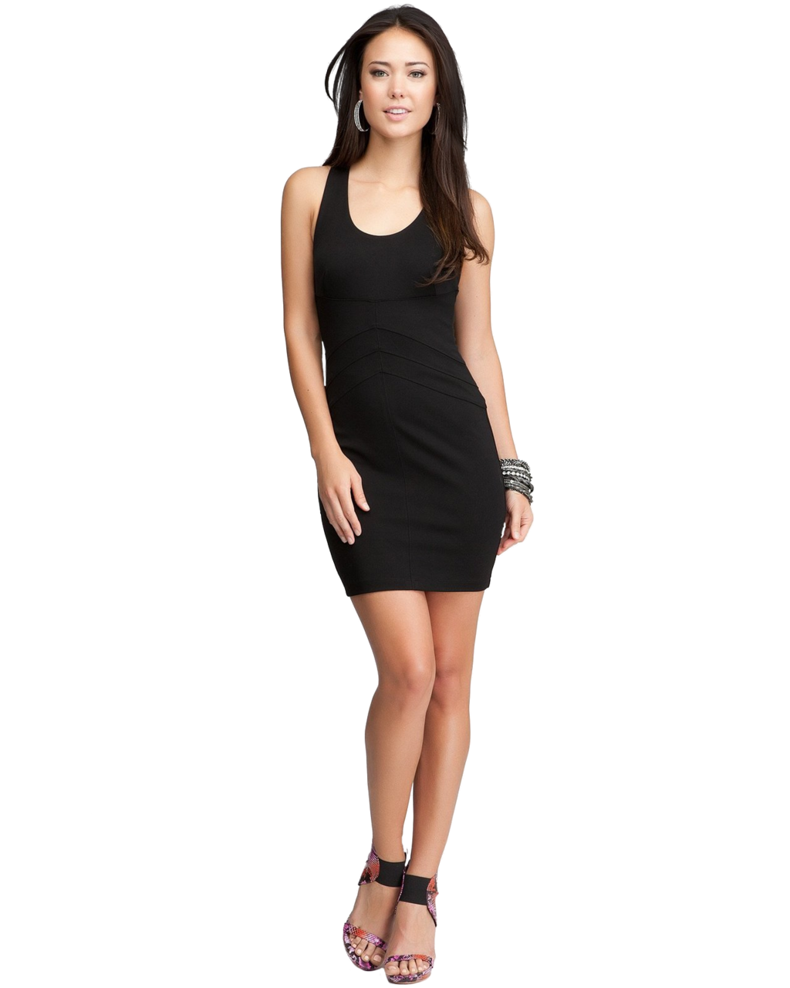

|  |
| --- |
| Ankle |
| ball of foot |
| calf |
| cheek |
| chest |
| elbow |
| forearm |
| forehead |
| Groin |
| index finger |
| knee |
| Knuckle |
| middle finger |
| Naval |
| nose |
| palm of hand |
| pinky or little finger |
| ring finger |
| shoulder |
| sole of foot |
| temple |
| thigh |
| thumb |
| toe |
| waist |
| wrist |

Chapter 2: Asepsis

CDC Guidelines for Hand Hygiene box 2-1

1. hand washing alcohol or sanitizer

|  |  |
| --- | --- |
|  |  |
|  |  |
|  |  |

***Procedure 2: 2 Hand washing & sterilizing***

***Signed by:***

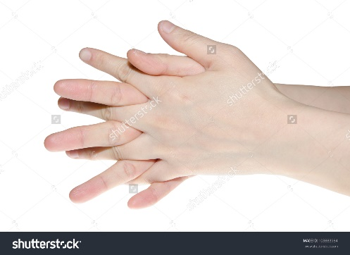

***Procedure 2: 2 Removing Gloves***

***Signed by:***

Personal Protective Equipment (PPE)

1. Which of these situations would need gloves?
   1. Performing a urinalysis on a urine specimen that contains blood.
   2. Sanitizing operating scissors for sterilization
   3. Performing a finger puncture.
   4. Performing a vision screening test on a school-aged child.
   5. Cleaning up a blood spill on a laboratory work table.
   6. Drawing blood from an elderly patient.
   7. Measuring the weight of a college student.
   8. Testing a blood specimen for glucose.

OSHA Terminology: Match the OSHA definitions:

1. Parenteral
2. Bloodborne Pathogens
3. Other potentially infection materials (OPIM)
4. Contaminated
5. Exposure incident
6. Germs that cause disease
7. Any body fluid: vaginal fluid, saliva, semen etc.
8. Piercing of the skin
9. Non-intact skin or Parental contact with blood or germs
10. Germs on a something

OSHA Post exposure guidelines & Needle stick Prevention Act

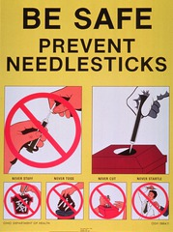4. If you stick yourself with a contaminated needle, what are the first 3 things to do?

1.)

2.)

3.)

REGULATED MEDICAL WASTE

Where would each item be discarded: Regular, Biohazard, Sharps or Toilet?

1. Urine testing strip
2. Lancet
3. Gloves with blood on them
4. Blood tube
5. Tongue depressor
6. Razor blade
7. Capillary pipet
8. Dressing saturated with blood
9. Patient drape
10. An empty urine container
11. Sutures caked with blood
12. Thermometer probe cover
13. Patient gown
14. Disposable diaper
15. Dressing saturated with a purulent discharge
16. Clean disposable gloves
17. Disposable vaginal speculum
18. An outdated vaccine
19. Syringe and needle
20. Examining-table paper

Disposal of Regulated Medical Waste

1. Place bags and sharps into a receptacle provided by the
2. Store biohazards in a ­­­­­­­­­­­­­­­­_____________________________________________________________

BLOOD BORNE DISEASES

Hepatitis B

1. Hepatitis B is the infection of the
2. The most common means of transmitting Hepatitis B at work is
3. The best way to prevent infection of Hepatitis B is

HIV/ AIDS

1. Two ways to get AIDS are

Can your kitchen pass the food safety test?

1. The temperature of the refrigerator in my home is:

A.) 50° Fahrenheit (degrees Celsius) C.) I don’t know; I’ve never measured it.

B.) 40° F (4° C)

1. The last time we had leftover cooked stew or other food with meat, chicken, or fish the food was:

A.) Cooled to room temperature C.)Left at room temperature overnight or longer

B.) Put in the refrigerator immediately after the food was served

1. The last time the kitchen sink drain, disposal, and connecting pipe in my home were sanitized was:

A.) Last night C.) Can’t remember

B.) Several weeks ago

1. If a cutting board is used in my home to cut raw meat, poultry, or fish and it is going to be used to chop another food, the board is:

A.) Reused as is C.) Washed with soap and hot water

B.) Wiped with a damp cloth

1. The last time we had hamburgers in my home, I ate mine:

A.) Rare C.) Well-done

B.) Medium

1. The last time there was cookie dough in my home, the dough was:

A.) Made with raw eggs C.) Not sampled until baked

B.) Store-bought

1. I clean my kitchen counters and other surfaces that come in contact with food with:

A.) Water C.) Hot water and soap, then bleach solution

B.) Hot water ad soap

1. When dishes are washed in my home they are:

A.) Cleaned by an automatic dish-washer

C.) Washed right away with hot water and soap in the sink and then air dried

B.)Left to soak in the sink for several hours and then washed with soap in the same water

1. The last time I handled raw meat, poultry , or fish, I cleaned my hands afterwards by:

A.) Wiping them on a towel C.) Washing with soap and water

B.) Rinsing them under hot, cold, or warm water

1. Meat, poultry, and fish products are defrosted in my home by

A.) Setting them on the counter B.) Placing them in the refrigerator C.) Microwaving

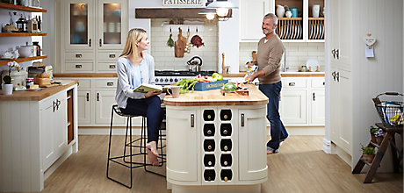

Your Score = _______________________